PLX image online update programming Guide

A: checking the Bus number of PLX 8796(U1000), PLX8796(U1001) and PLX8750(U1006) of system in first step.

1. Boot the system to DOS.
2. Run Ru.exe
3. Press F6 to list all the PCI device when RU.exe is running
4. Move the key board to Bus#00 Dev#01 Fun#00,this is the root port of PLX8750(U1006).like this:

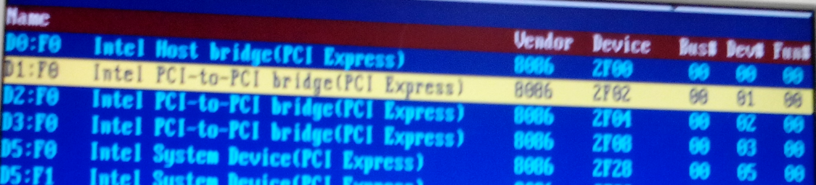

1. Press “Enter” key, into the following window, the value in offset ox19 is the BUS number of PLX8750(U1006), the value in my system is 0x01, so the BUS number of PLX8750 is the 0x01.

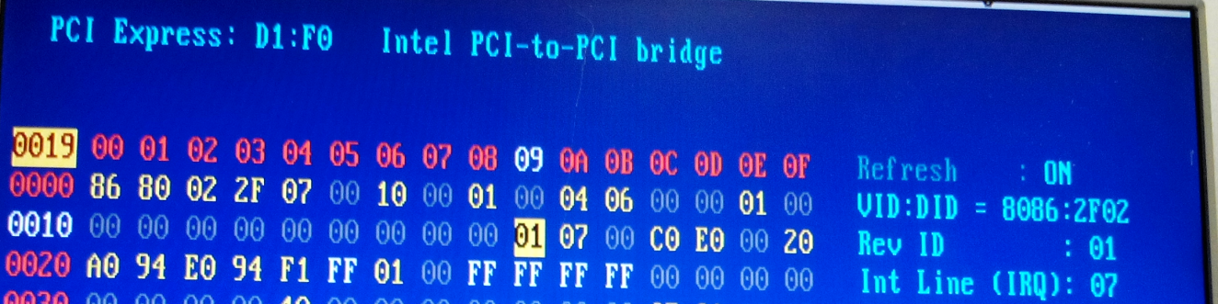

1. Press F6 to list the PCI device again. Move the keyboard to Bus#00 Dev#02 Fun#00, this is the root port of PLX8796(U1001).like this:

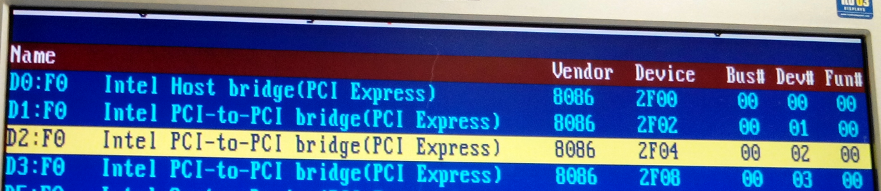

1. Repeat Step5, the value in offset ox19 is the BUS number of PLX8796(U1001), the value in my system is 0x08, so the BUS number of PLX8796(U1001) is the 0x08.

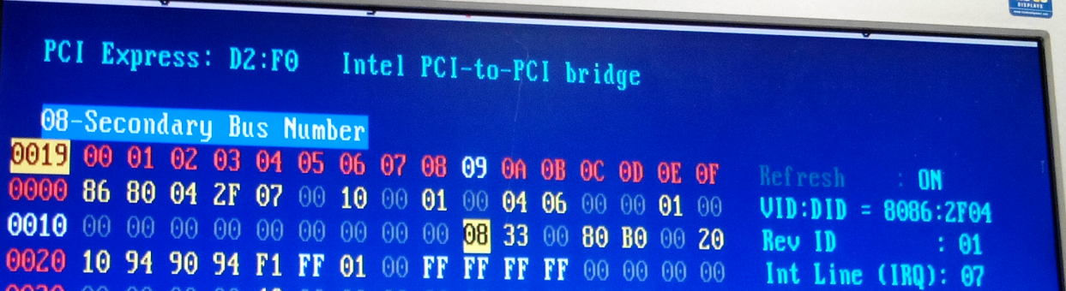

1. Press F6 to list the PCI device again. Move the keyboard to Bus#00 Dev#03 Fun#00, this is the root port of PLX8796(U1000).like this:

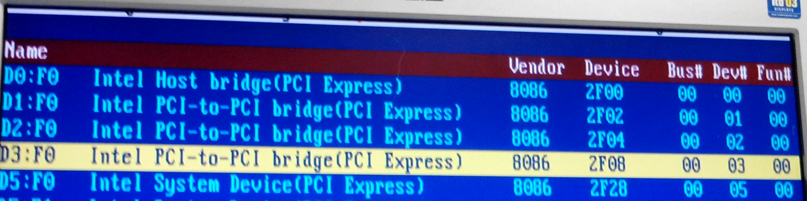

1. Repeat Step5, the value in offset ox19 is the BUS number of PLX8796(U1000), the value in my system is 0x34, so the BUS number of PLX8796(U1000) is the 0x34.

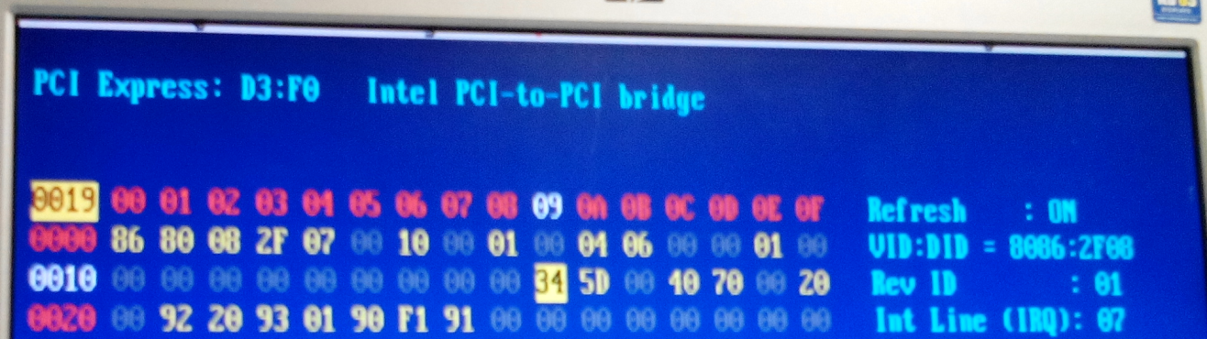

1. We have got the Bus number of the PLX device which we needs programming till now. Please make a memo of thus Bus number.

PLX8750(U1006) Bus number is 0x01

PLX8796(U1001) Bus number is 0x08

PLX8796(U1000) Bus number is 0x34

B: Online Programming ROM

<a> Programming ROM U112. U112 is the EEPROM of PLX8796(U1000).

1. Boot the system to DOS.
2. Run U112.bat, the tool will list all PLX8796 devices in following window, checking the device number which we needs programming the EEPROM and enter the Device number.

In our system, PLX8796(U1000)’s Bus number is 0x34, so the Device selection number is 6, enter number 6 here.

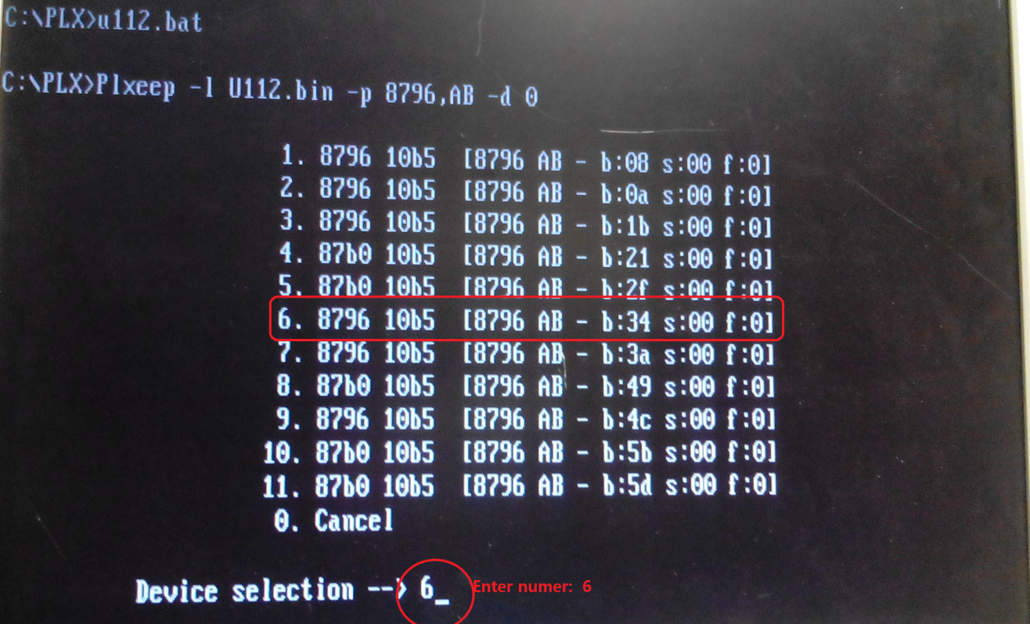

1. Press “enter” key after fill in the Device selection number. The tool will program the EEPROM auto. And out put the successfully info, the U112 is be programmed.

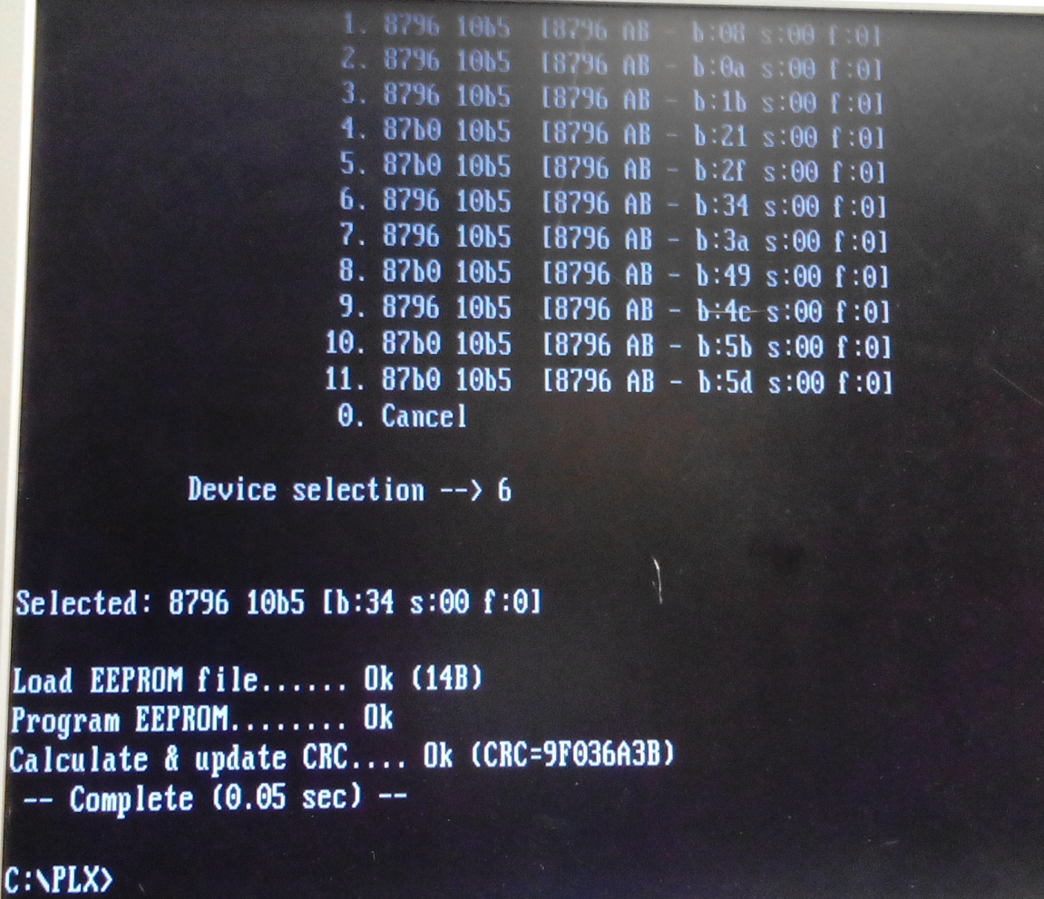

<b> Programming ROM U187. U187 is the EEPROM of PLX8796(U1001), the process likes Step <a>.

1. Boot the system to DOS.
2. Run U187.bat, the tool will list all PLX8796 devices in following window, checking the device number which we needs programming the EEPROM and enter the Device number.

In our system, PLX8796(U1001)’s Bus number is 0x8, so the Device selection number is 1, enter number 1 here.

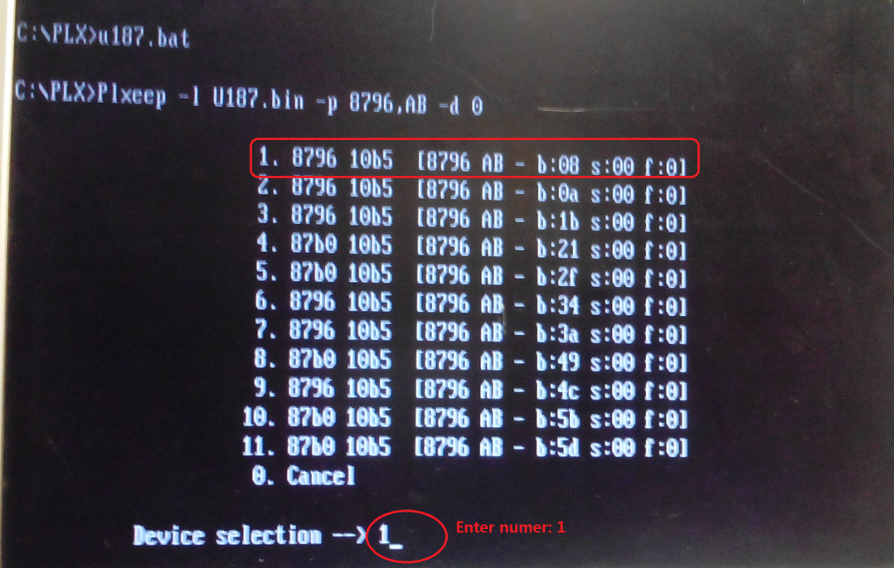

1. Press “enter” key after fill in the Device selection number. The tool will program the EEPROM auto. And out put the successfully info, the U187 is be programmed

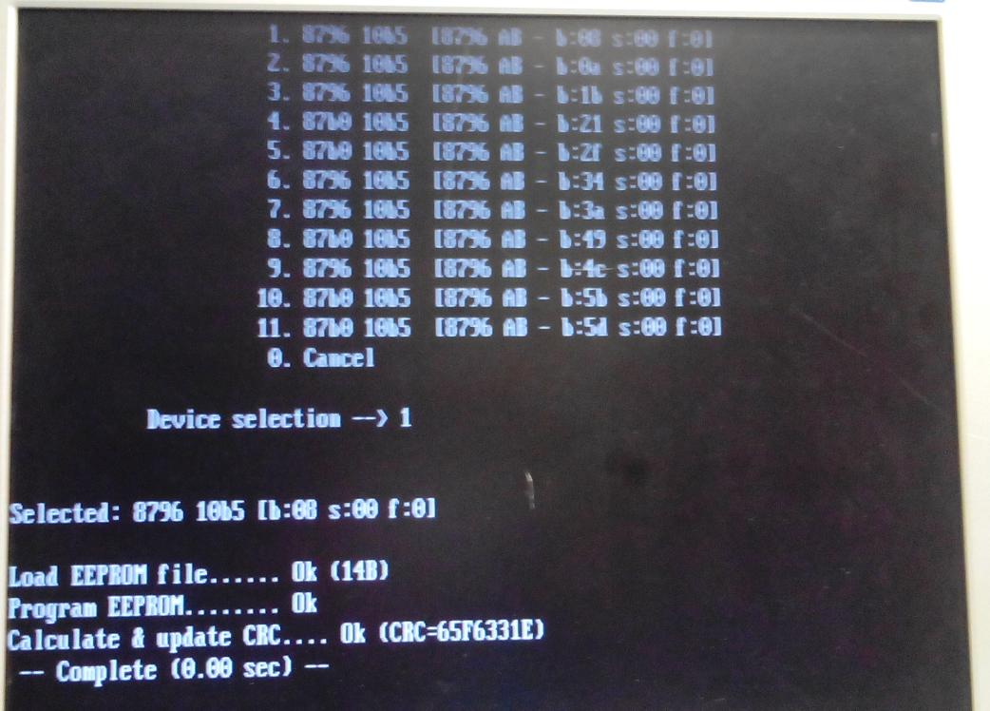

<c> Programming ROM U199. U99 is the EEPROM of PLX8750(U1006), the process likes Step <a>.

1. Boot the system to DOS.
2. Run U187.bat, the tool will list all PLX8796 devices in following window, checking the device number which we needs programming the EEPROM and enter the Device number.

In our system, PLX8750 (U1006)’s Bus number is 0x1, so the Device selection number is 1, enter number 1 here.

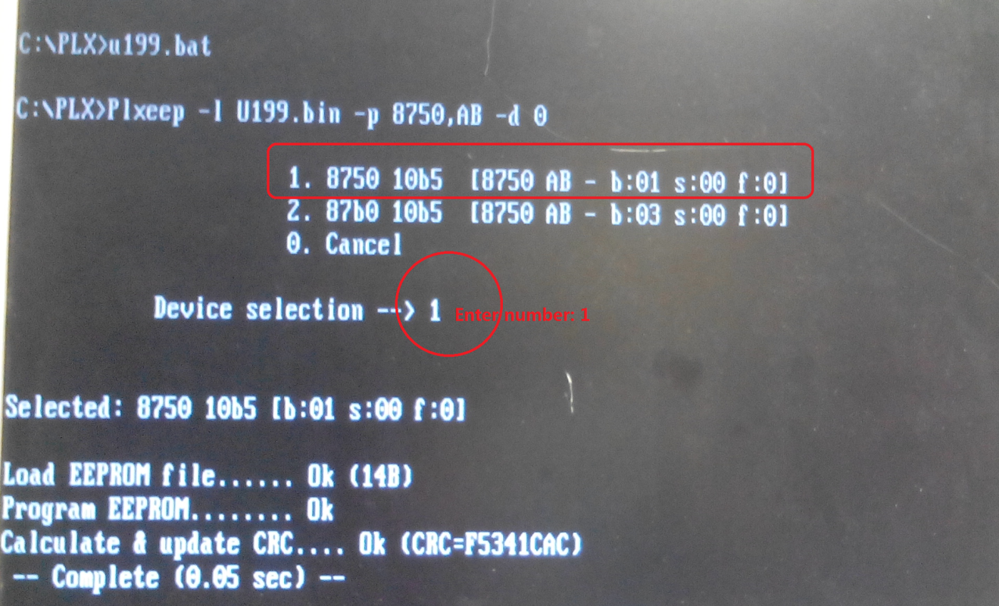

1. Press “enter” key after fill in the Device selection number. The tool will program the EEPROM auto. And out put the successfully info, the U199 is be programmed